AIM: Home Automation using Bluetooth

Block Diagram:

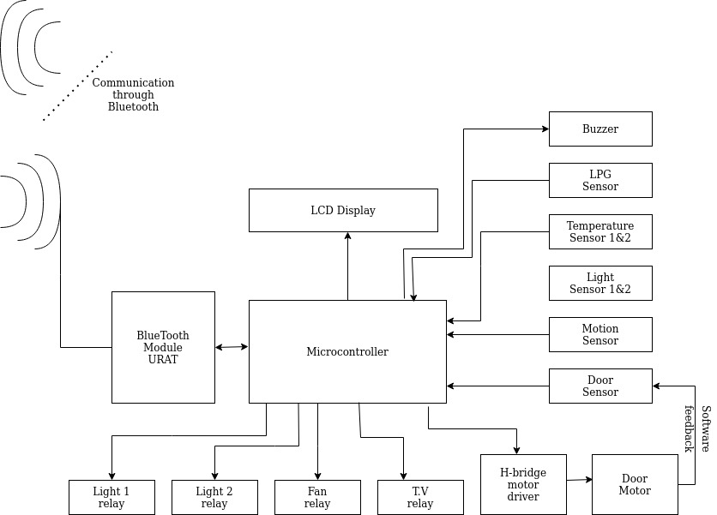
Smart
Phone

Code:

CODE FOR HOME AUTOMATION C/C++
TYPED ON ARDUINO IDE
float x,y;
//TEMP
#define trigPin 12
//ULTRA
#define echoPin 10
int ledPin= 13;
int duration, distance; //ULTRA
#include<Servo.h>
Servo my;
//servo
//servo
char val;
//bluetooth
void setup() {
Serial.begin(9600);
pinMode(2,INPUT); //IR GATE FIRST
pinMode(3,INPUT);
my.attach(11);
//servo
pinMode(4, OUTPUT);
//IR GATE FIRST
pinMode(7,OUTPUT);
//TEM
pinMode(8,INPUT);
//pir 1
pinMode(9,OUTPUT);
//LED 1
// pinMode(10,INPUT);
//pir 2
//pinMode(11,OUTPUT);
//LED2
pinMode(trigPin, OUTPUT); //12 PIN ULTRA
pinMode(echoPin, INPUT); //10 PIN ULTRA
pinMode(ledPin, OUTPUT); //13 PIN ULTRA
pinMode(3,OUTPUT);
//bluetooth
}
void loop() {
x=analogRead(0);
y=((x/1024)*5)*100;
Serial.println(y);
delay(500);
//TEMP
if(y>44)
{
digitalWrite(7,1);
}
else
{
digitalWrite(7,0);
delay(500);
}
//TEMP
if(digitalRead(8)==HIGH)
{
digitalWrite(9,HIGH);
}
else
{ digitalWrite(9,LOW);}
digitalWrite(trigPin, HIGH);
delayMicroseconds(10);
digitalWrite(trigPin, LOW);
duration = pulseIn(echoPin, HIGH);
distance = (duration/2) / 29.1;
//ULTRA
if (distance >= 10 || distance <= 0)
{
// Serial.println("no object detected");
digitalWrite(ledPin,LOW);
}
else
{
Serial.println("object detected \n");
Serial.print("distance= ");
Serial.print(distance);
digitalWrite(ledPin,HIGH);
}
if(digitalRead(2)==HIGH)
//gate first
{
my.write(0);
//servo
}
else
{
my.write(90);
}
analogRead(5);
float a = analogRead(5);
Serial.println(a);
//ULTRA
//servo
//ldr
if (a <=200) {
digitalWrite(4,1);
Serial.println("LDR is DARK, LED is ON");
}
else {
digitalWrite(4,0);
Serial.println("-----");
}
if (Serial.available())
{
val = Serial.read();
Serial.println(val);
if(val == 'TV')
digitalWrite(3,HIGH);
else if(val == 'tv')
digitalWrite(3,LOW);
}
}

Result: Coding and block diagram for Home automation using bluetooth was done

